Line in Solid Geometry

Definition
# Source: AI Source: Provided by: [Data Path: Persons Table -> ID Column: 1, Name_En Column: Motasem Essam] -> From: [ChatGPT] on [7/25/2026]
A Line in Solid Geometry is a straight, one-dimensional geometric object that extends infinitely in both directions through three-dimensional space. It has length but no width or thickness.
A line can pass through points, lie within a plane, or extend through multiple planes in space.

Simple Definition
# Source: AI Source: Provided by: [Data Path: Persons Table -> ID Column: 1, Name_En Column: Motasem Essam] -> From: [ChatGPT] on [7/25/2026]
A line is a straight path that continues forever in both directions, with no endpoints.
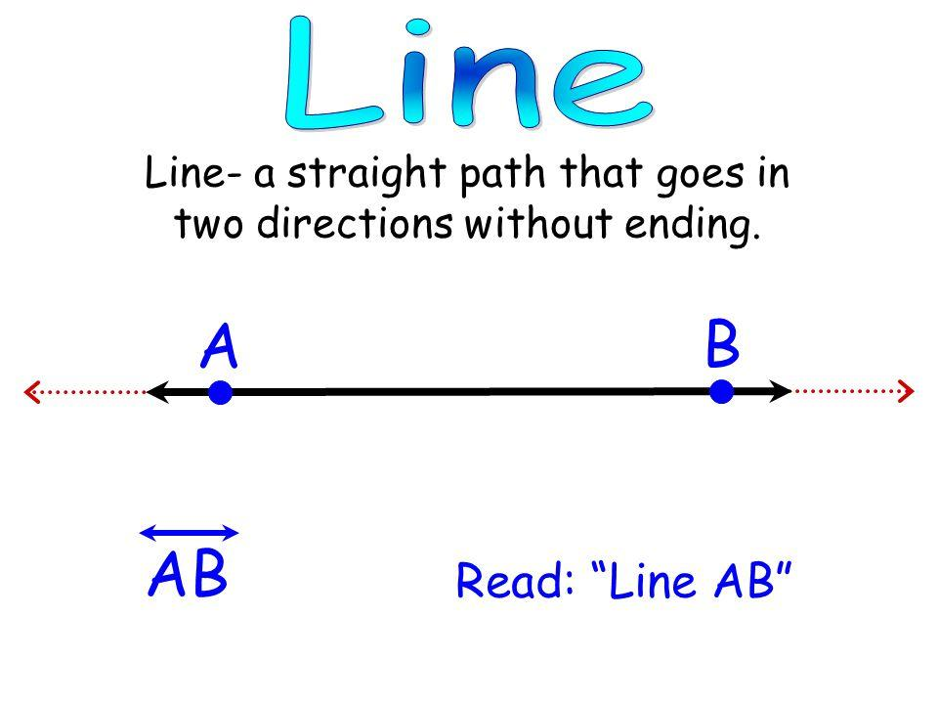
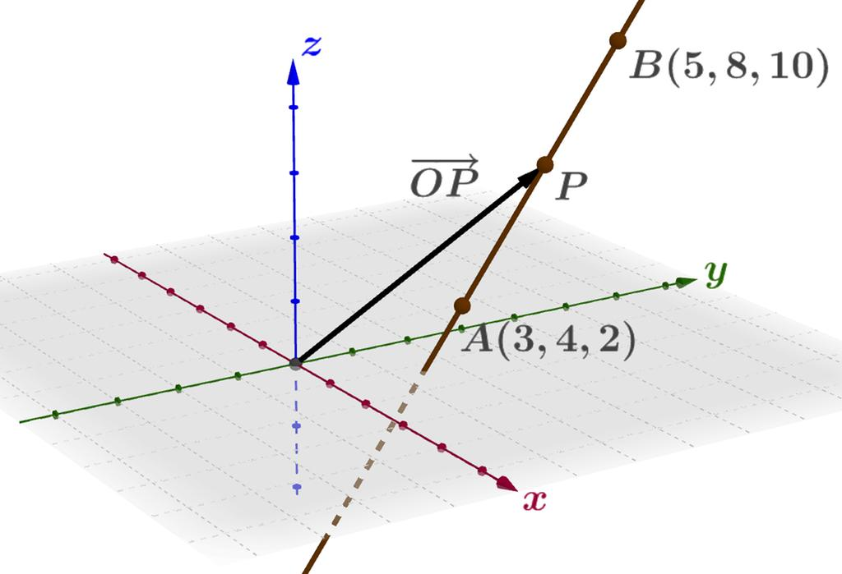
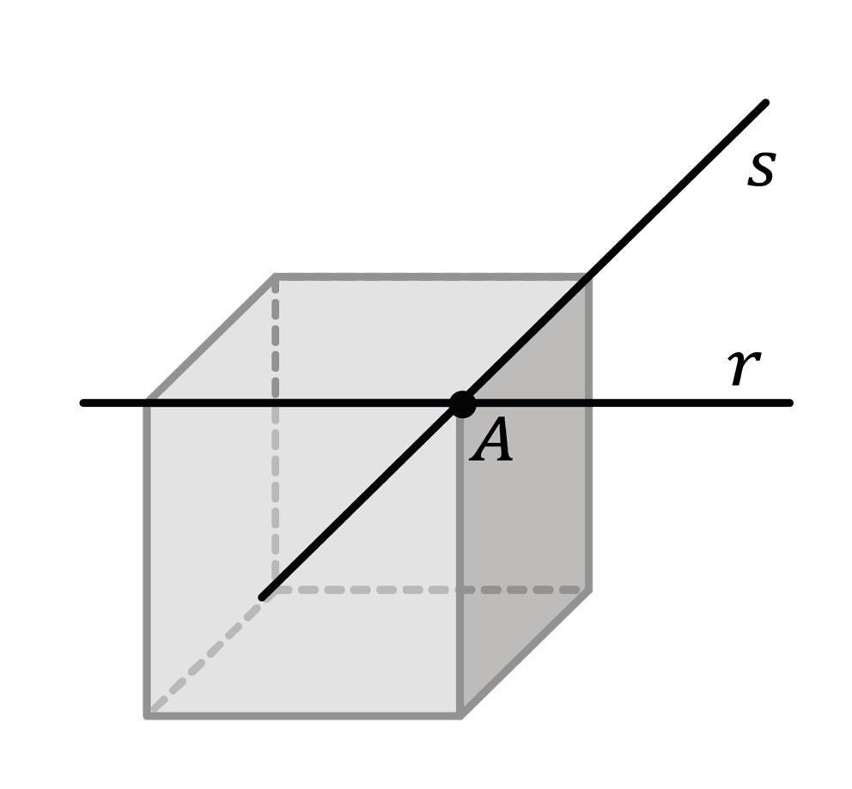

Fundamental Properties
# Source: AI Source: Provided by: [Data Path: Persons Table -> ID Column: 1, Name_En Column: Motasem Essam] -> From: [ChatGPT] on [7/25/2026]
- One-Dimensional: A line has length but no width or thickness.
- Infinite Extent: A mathematical line extends without end in both directions.
- Straightness: A line has no curvature; its direction remains constant.
- No Endpoints: Unlike a line segment, a line has no endpoints.
- Determined by Two Points: Two distinct points determine exactly one straight line in Euclidean geometry.
- Direction: A line in space has a direction that can be represented by a vector.

Main Types of Lines in Solid Geometry
# Source: AI Source: Provided by: [Data Path: Persons Table -> ID Column: 1, Name_En Column: Motasem Essam] -> From: [ChatGPT] on [7/25/2026]
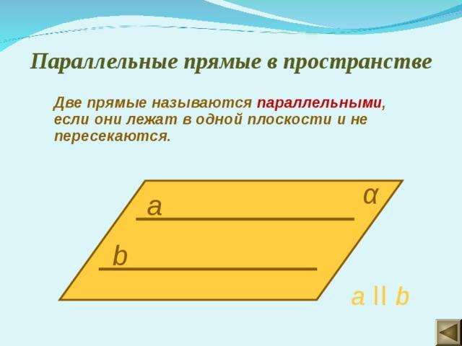
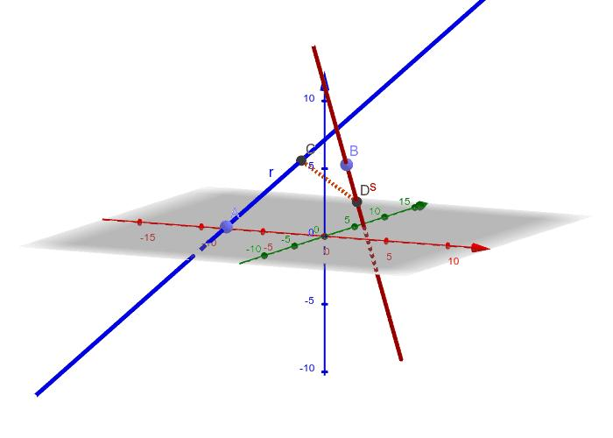
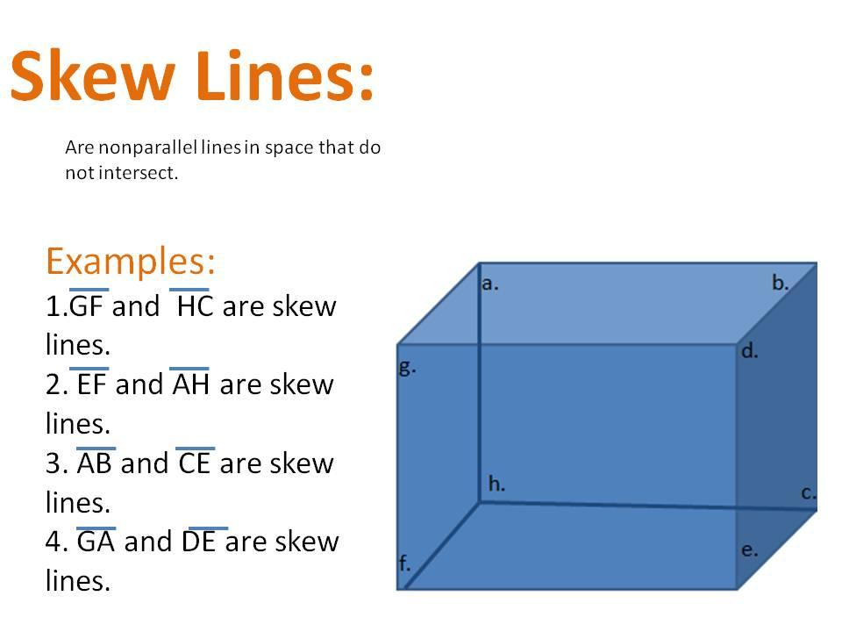
6

1. Line in Space
# Source: AI Source: Provided by: [Data Path: Persons Table -> ID Column: 1, Name_En Column: Motasem Essam] -> From: [ChatGPT] on [7/25/2026]
A line in space is a straight line located anywhere in three-dimensional space. It does not have to lie entirely within a particular plane.

2. Parallel Lines
# Source: AI Source: Provided by: [Data Path: Persons Table -> ID Column: 1, Name_En Column: Motasem Essam] -> From: [ChatGPT] on [7/25/2026]
Two distinct lines are parallel if they lie in the same plane and never intersect.
Their directions are parallel, even if the lines are at different positions.

3. Intersecting Lines
# Source: AI Source: Provided by: [Data Path: Persons Table -> ID Column: 1, Name_En Column: Motasem Essam] -> From: [ChatGPT] on [7/25/2026]
Two lines intersect when they share a point.
If two intersecting lines meet at a right angle, they are called perpendicular lines.

4. Skew Lines
# Source: AI Source: Provided by: [Data Path: Persons Table -> ID Column: 1, Name_En Column: Motasem Essam] -> From: [ChatGPT] on [7/25/2026]
Skew lines are lines in three-dimensional space that do not intersect and are not parallel. They do not lie in the same plane.
For example, certain opposite edges of a cube are skew lines.

5. Coplanar Lines
# Source: AI Source: Provided by: [Data Path: Persons Table -> ID Column: 1, Name_En Column: Motasem Essam] -> From: [ChatGPT] on [7/25/2026]
Coplanar lines are lines that lie in the same plane. They may be parallel, intersecting, or coincident.

6. Coincident Lines
# Source: AI Source: Provided by: [Data Path: Persons Table -> ID Column: 1, Name_En Column: Motasem Essam] -> From: [ChatGPT] on [7/25/2026]
Coincident lines occupy exactly the same geometric line, sharing every point.

Position of a Line Relative to a Plane
# Source: AI Source: Provided by: [Data Path: Persons Table -> ID Column: 1, Name_En Column: Motasem Essam] -> From: [ChatGPT] on [7/25/2026]
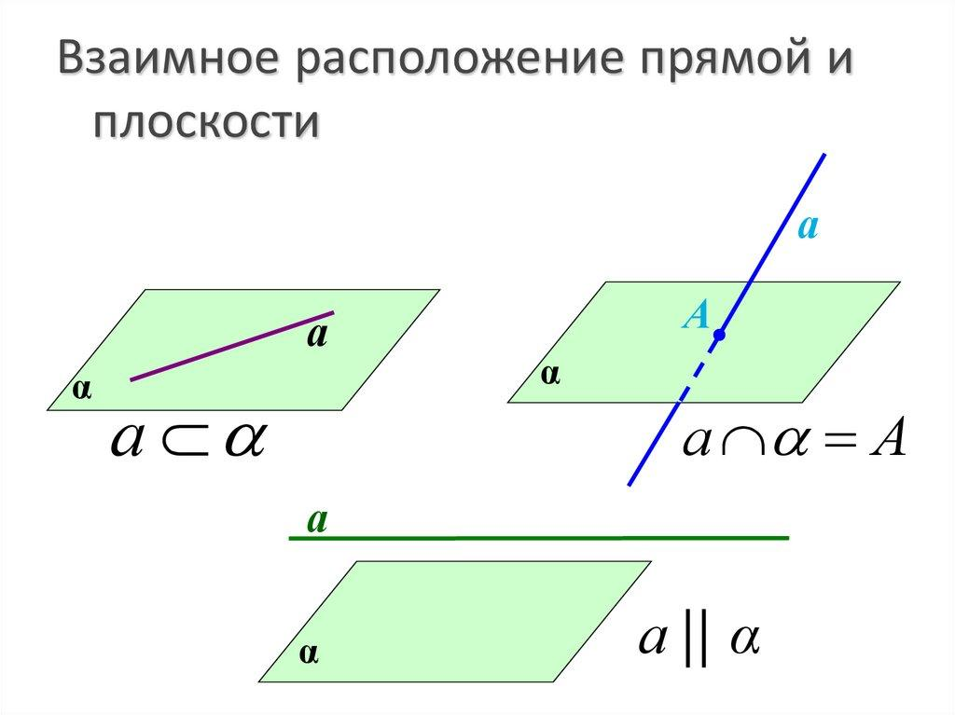
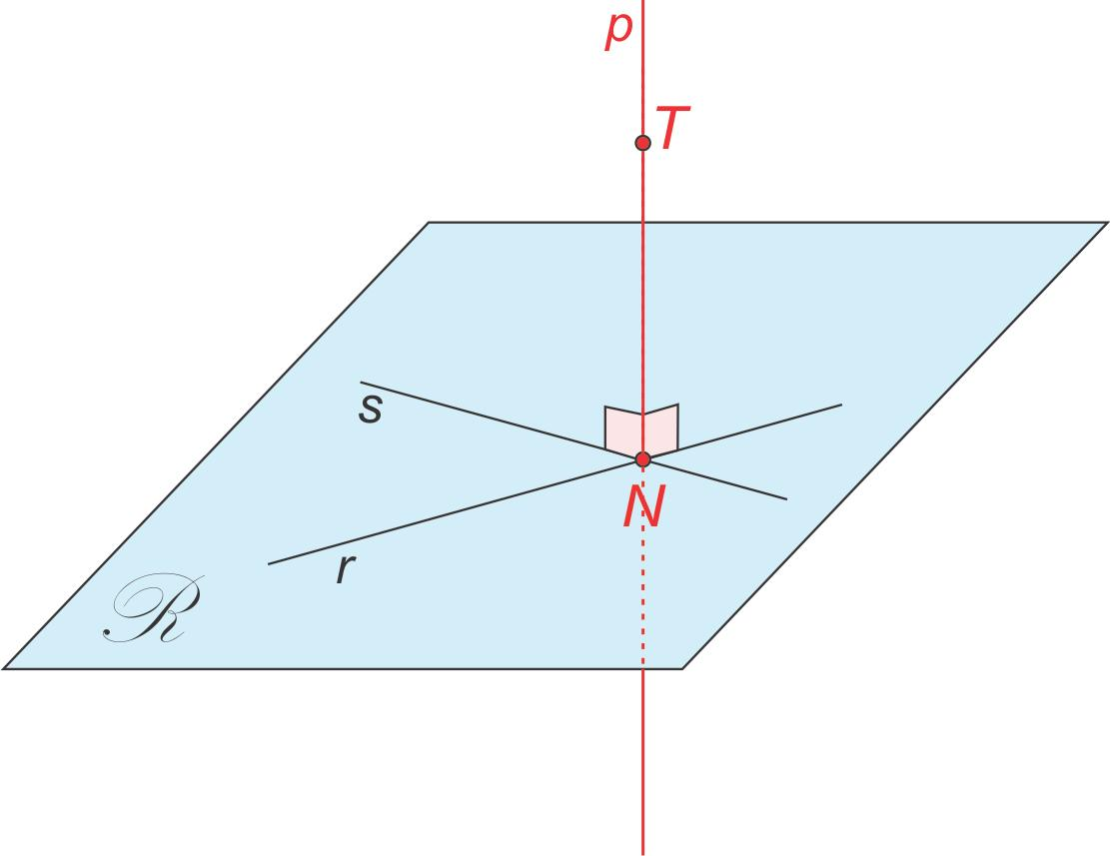
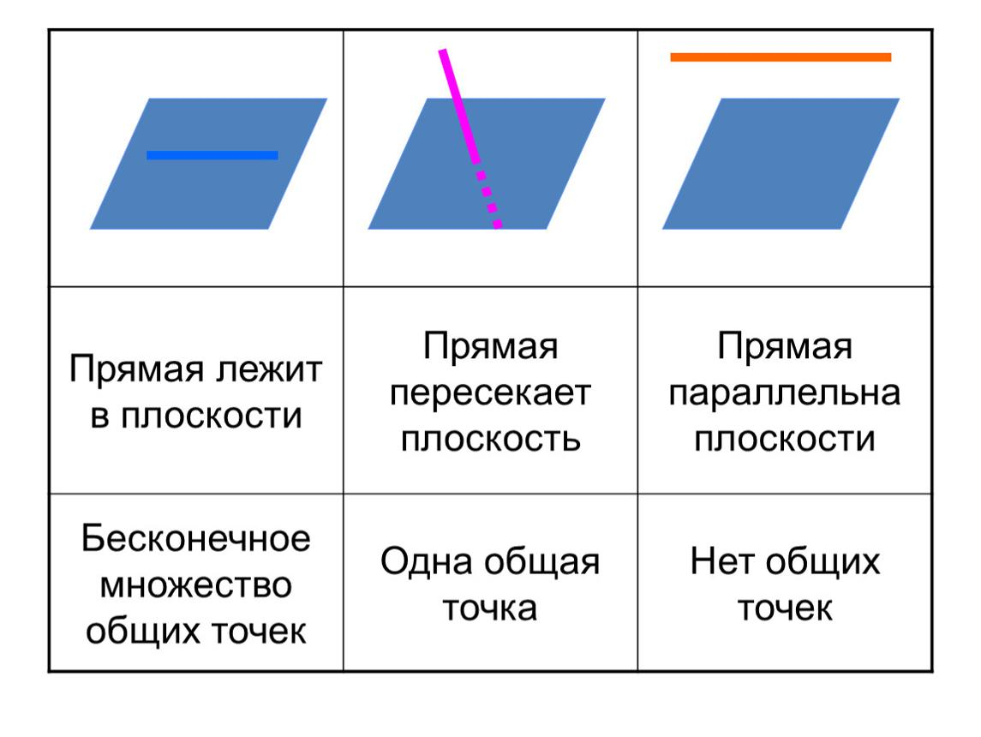
A line and a plane in three-dimensional space can have several relationships.
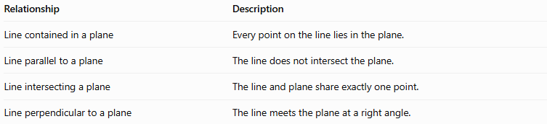
Relationship | Description
Line contained in a plane | Every point on the line lies in the plane.
Line parallel to a plane | The line does not intersect the plane.
Line intersecting a plane | The line and plane share exactly one point.
Line perpendicular to a plane | The line meets the plane at a right angle.
A line that intersects a plane at a right angle is a special case of a line intersecting a plane.

Representation of a Line in Three-Dimensional Coordinates
# Source: AI Source: Provided by: [Data Path: Persons Table -> ID Column: 1, Name_En Column: Motasem Essam] -> From: [ChatGPT] on [7/25/2026]
A line in three-dimensional Cartesian space can be represented using a point and a direction vector.
Suppose the line passes through point $P_{0}=\left(x_{0},y_{0},z_{0}\right)$ and has direction vector
$$v=\left(a,b,c\right)$$
Its parametric equations are
$$\begin{aligned}x&=x_{0}+at \\ y&=y_{0}+bt t∈R \\ z&=z_{0}+ct\end{aligned}$$

Here, $t$ is a real parameter that identifies points along the line.
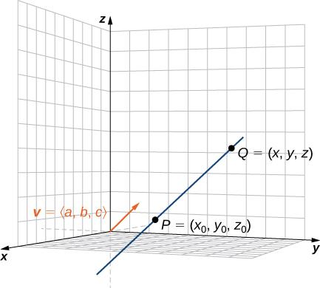
Example
Consider the line passing through $P_{0}=\left(1,2,3\right)$ with direction vector $v=\left(2,1,-1\right)$.
Its parametric equations are
$$\begin{aligned}x&=1+2t \\ y&=2+t \\ z&=3-t\end{aligned}$$
When $t=0$, the point is $\left(1,2,3\right)$. When $t=1$, the point is $\left(3,3,2\right)$.
Both points lie on the same line.

Important Relationships and Theorems

1 Two Points Determine a Line
# Source: AI Source: Provided by: [Data Path: Persons Table -> ID Column: 1, Name_En Column: Motasem Essam] -> From: [ChatGPT] on [7/25/2026]
Through any two distinct points in Euclidean space, exactly one straight line can be drawn.

2 Parallel Line Property
# Source: AI Source: Provided by: [Data Path: Persons Table -> ID Column: 1, Name_En Column: Motasem Essam] -> From: [ChatGPT] on [7/25/2026]
Two distinct parallel lines in Euclidean space are coplanar and never intersect.

3 Intersecting Lines Determine a Plane
# Source: AI Source: Provided by: [Data Path: Persons Table -> ID Column: 1, Name_En Column: Motasem Essam] -> From: [ChatGPT] on [7/25/2026]
Two distinct intersecting lines determine exactly one plane.

4 Skew Line Property
# Source: AI Source: Provided by: [Data Path: Persons Table -> ID Column: 1, Name_En Column: Motasem Essam] -> From: [ChatGPT] on [7/25/2026]
Skew lines are non-coplanar lines that neither intersect nor run parallel to one another.

5 Line and Plane Relationship
# Source: AI Source: Provided by: [Data Path: Persons Table -> ID Column: 1, Name_En Column: Motasem Essam] -> From: [ChatGPT] on [7/25/2026]
A line that is not contained in a plane either intersects the plane at one point or is parallel to it.

Line vs. Line Segment vs. Ray
# Source: AI Source: Provided by: [Data Path: Persons Table -> ID Column: 1, Name_En Column: Motasem Essam] -> From: [ChatGPT] on [7/25/2026]
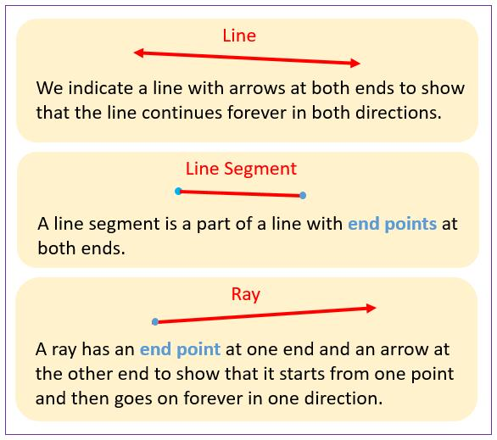
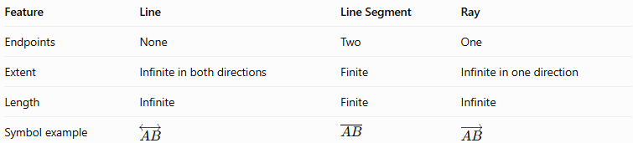
Feature | Line | Line Segment | Ray
Endpoints | None | Two | One
Extent | Infinite in both directions | Finite | Infinite in one direction
Length | Infinite | Finite | Infinite
Symbol example | $$\overset{↔}{AB}$$ | $$\overline{AB}$$ | $$\overset{→}{AB}$$
A line segment is the finite portion between two points. A ray begins at one endpoint and extends infinitely in one direction.

Constructing Line in Solid Geometry

Instruments Used
# Source: AI Source: Provided by: [Data Path: Persons Table -> ID Column: 1, Name_En Column: Motasem Essam] -> From: [ChatGPT] on [7/25/2026]
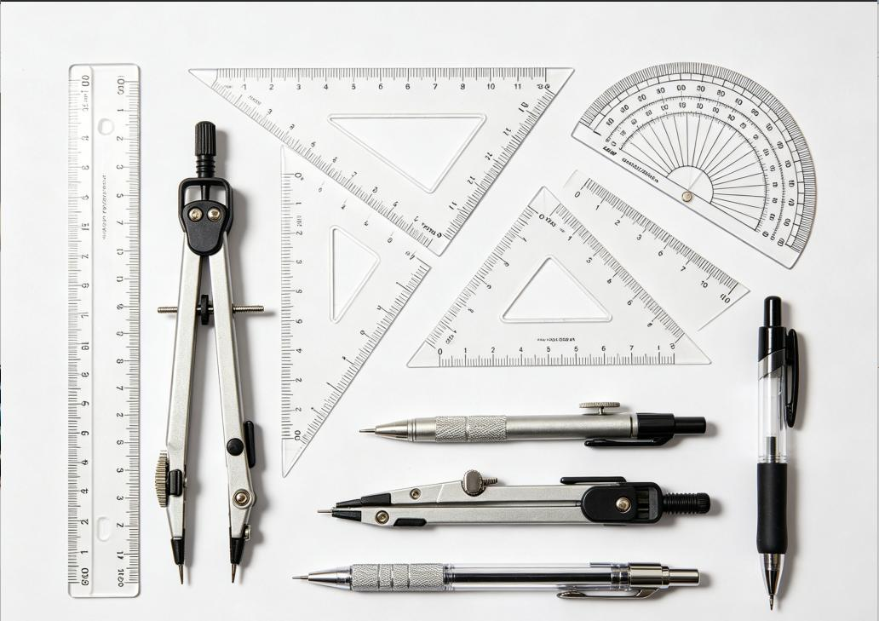
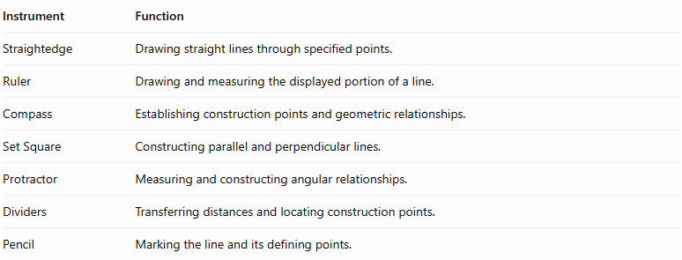
Instrument | Function
Straightedge | Drawing straight lines through specified points.
Ruler | Drawing and measuring the displayed portion of a line.
Compass | Establishing construction points and geometric relationships.
Set Square | Constructing parallel and perpendicular lines.
Protractor | Measuring and constructing angular relationships.
Dividers | Transferring distances and locating construction points.
Pencil | Marking the line and its defining points.

Construction Procedures

Constructing a Line Through Two Given Points
# Source: AI Source: Provided by: [Data Path: Persons Table -> ID Column: 1, Name_En Column: Motasem Essam] -> From: [ChatGPT] on [7/25/2026]
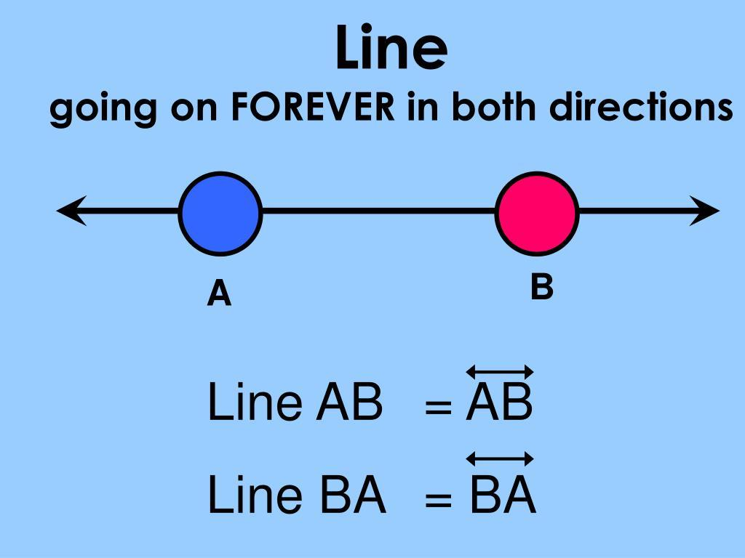
- Mark two distinct points $A$ and $B$.
- Place a straightedge through both points.
- Draw a straight path passing through $A$ and $B$.
- Extend the displayed path beyond both points.
- Add arrowheads at both ends.
- Label the line $overleftrightarrowAB$.

Constructing a Parallel Line
# Source: AI Source: Provided by: [Data Path: Persons Table -> ID Column: 1, Name_En Column: Motasem Essam] -> From: [ChatGPT] on [7/25/2026]
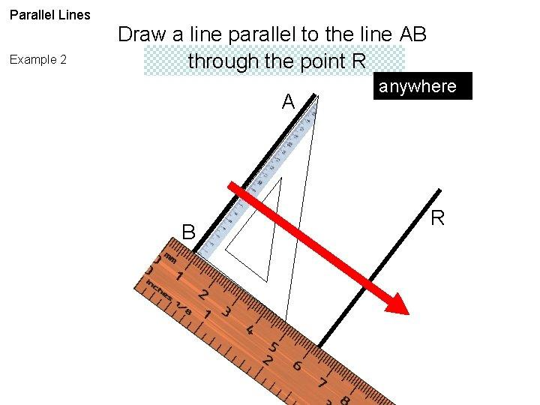
- Identify the given line.
- Mark a point outside the given line through which the new line must pass.
- Position a set square against the reference line.
- Slide it while maintaining the same direction.
- Draw the new line through the marked point.
- Extend it in both directions.

Constructing a Perpendicular Line
# Source: AI Source: Provided by: [Data Path: Persons Table -> ID Column: 1, Name_En Column: Motasem Essam] -> From: [ChatGPT] on [7/25/2026]
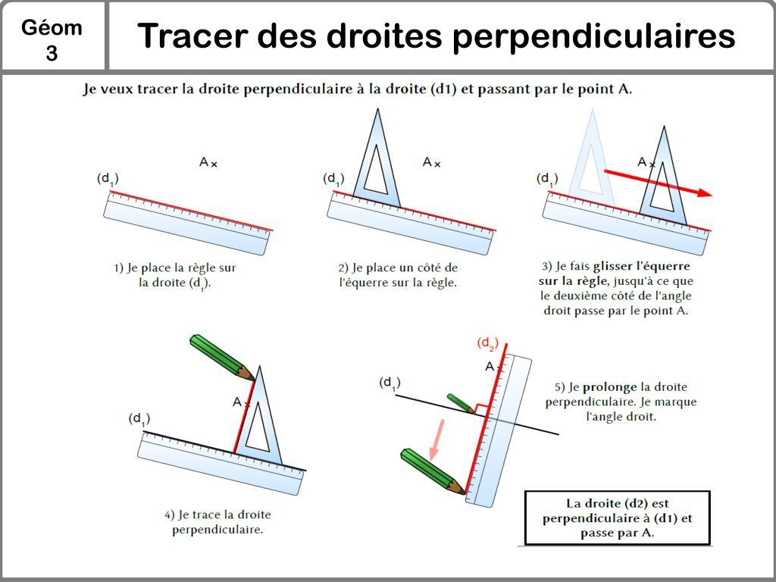
- Identify the reference line.
- Mark the required intersection point or external point.
- Position a set square to establish a right angle.
- Draw the perpendicular line.
- Extend it in both directions.
- Mark the right angle if necessary.

Constructing an Angle-Based Line
# Source: AI Source: Provided by: [Data Path: Persons Table -> ID Column: 1, Name_En Column: Motasem Essam] -> From: [ChatGPT] on [7/25/2026]
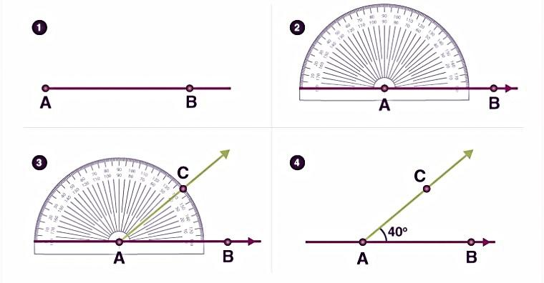
- Mark the required point through which the line must pass.
- Establish a reference line or direction.
- Position the protractor at the required point.
- Mark the specified angle.
- Draw a straight path through the point at the required angle.
- Extend the path in both directions.

Constructing a Transversal Line
# Source: AI Source: Provided by: [Data Path: Persons Table -> ID Column: 1, Name_En Column: Motasem Essam] -> From: [ChatGPT] on [7/25/2026]
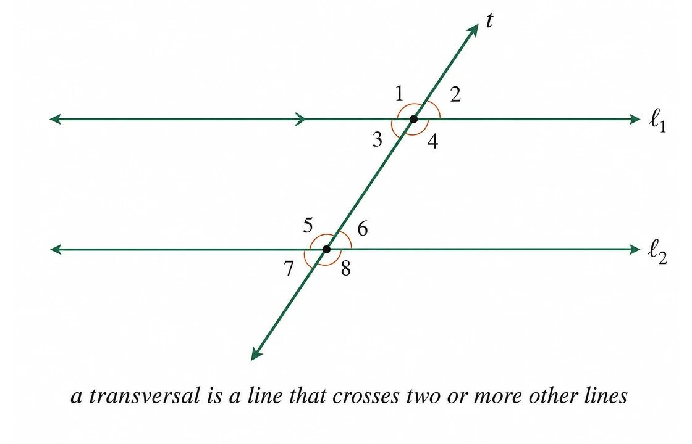
- Identify the lines that must be intersected.
- Determine the required intersection points.
- Position a straightedge through those points when they are collinear.
- Draw the straight path through the intersection points.
- Extend the line in both directions.

Constructing a Line in Three-Dimensional Space
# Source: AI Source: Provided by: [Data Path: Persons Table -> ID Column: 1, Name_En Column: Motasem Essam] -> From: [ChatGPT] on [7/25/2026]
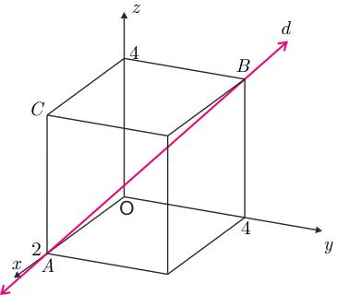
- Identify two distinct spatial points.
- Represent their positions in the three-dimensional geometric drawing.
- Determine the straight path passing through both points.
- Use the appropriate drawing instruments and projection views to represent that path.
- Extend the represented line in both directions.
- Add arrowheads to indicate its infinite extension.
Important: A physical straightedge produces a two-dimensional drawing. A spatial line is represented through suitable geometric views or projections; a single drawing does not necessarily establish its complete three-dimensional position.

Applications of Lines in Solid Geometry
# Source: AI Source: Provided by: [Data Path: Persons Table -> ID Column: 1, Name_En Column: Motasem Essam] -> From: [ChatGPT] on [7/25/2026]
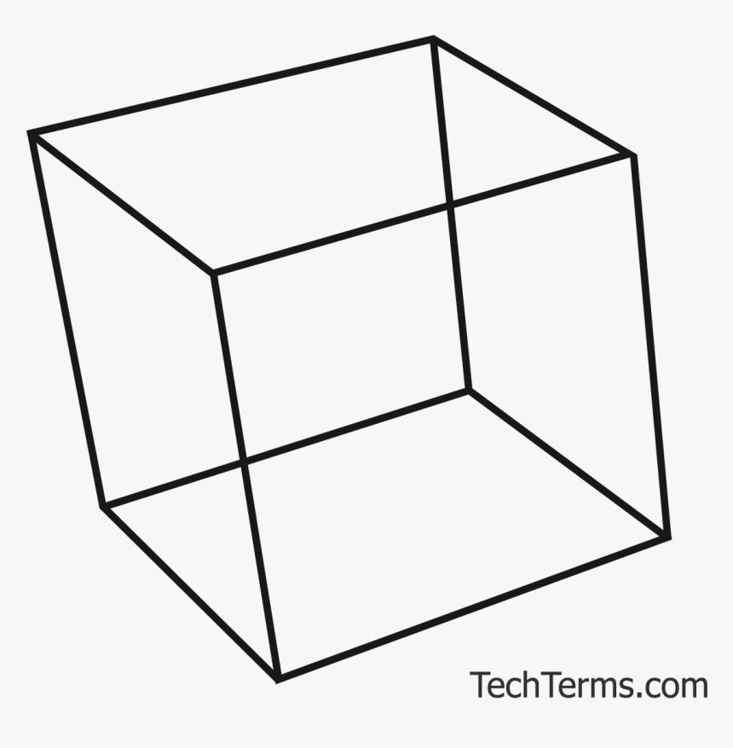
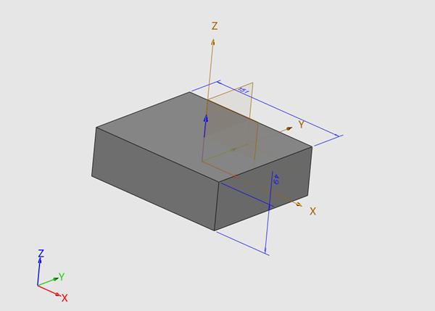
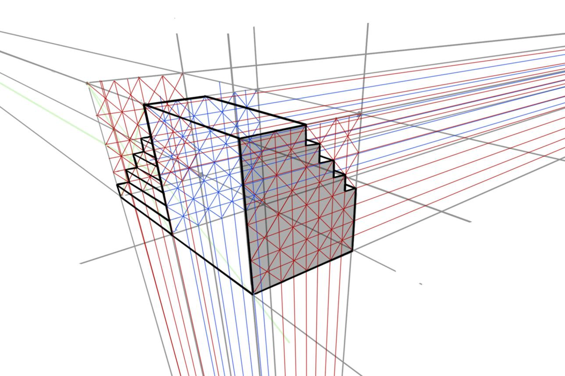
Lines are important in:
- Architecture: Defining directions, alignments, and structural layouts.
- Engineering: Describing axes, component alignment, and directions of movement.
- Coordinate Geometry: Representing straight paths mathematically in three dimensions.
- Computer Graphics: Calculating intersections, object visibility, and ray paths.
- Spatial Geometry: Determining parallelism, perpendicularity, and relationships between objects.

Key Points
# Source: AI Source: Provided by: [Data Path: Persons Table -> ID Column: 1, Name_En Column: Motasem Essam] -> From: [ChatGPT] on [7/25/2026]
- A line is a one-dimensional, straight geometric object extending infinitely in both directions.
- Two distinct points determine a unique line.
- Lines in space can be parallel, intersecting, coincident, or skew.
- A line can lie in a plane, intersect a plane, or be parallel to a plane.
- Three-dimensional lines can be represented using a point, a direction vector, and parametric equations.
- Lines form the basis for understanding edges, planes, and spatial relationships.

Conclusion
# Source: AI Source: Provided by: [Data Path: Persons Table -> ID Column: 1, Name_En Column: Motasem Essam] -> From: [ChatGPT] on [7/25/2026]
A Line in Solid Geometry is a fundamental geometric element used to describe straight directions and relationships in three-dimensional space. Unlike a line segment or a ray, it extends infinitely in both directions and has no endpoints.
Understanding lines makes it possible to analyze parallelism, intersections, perpendicularity, skew relationships, and the connections between lines and planes. Lines also provide a foundation for coordinate geometry, spatial measurement, engineering, architecture, and three-dimensional modeling.

